**Q1:SWAP 2 NUMBERS USING TEMPORARY VARIABLE**

**INPUT:**

**package dsA.JAVA;**

**import java.util.Scanner;**

**import java.util.Arrays;**

**public class ARR4 {**

**static void swap(int a,int b){**

**System.*out*.println("original values before swap is ");**

**System.*out*.println("a: "+a);**

**System.*out*.println("b: "+b);**

**int temp=a;**

**a=b;**

**b=a;**

**System.*out*.println("value after swaping is");**

**System.*out*.println("a :"+a);**

**System.*out*.println("b :"+b);**

**}**

**public static void main(String[] args) {**

**// q1**

**Scanner sc=new Scanner(System.*in*);**

**int a=9;**

**int b=3;**

***swap*(a,b);**

**}**

**}**

**OUTPUT:** 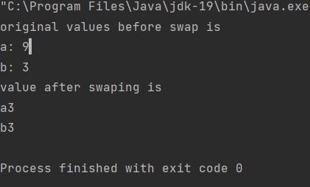

**Q2 SWAP WITHOUT USING TEMPORARY VARIABLE**

**CODE: static void swapSD(int a,int b){**

**System.*out*.println("original values before swap is ");**

**System.*out*.println("a: "+a);**

**System.*out*.println("b: "+b);**

**a=a+b;**

**b=a-b;**

**a=a-b;**

**System.*out*.println("value after swaping is");**

**System.*out*.println("a :"+a);**

**System.*out*.println("b :"+b);**

**}**

**public static void main(String[] args) {**

**// q1**

**Scanner sc=new Scanner(System.*in*);**

**int a=9;**

**int b=3;**

***swapSD*(a,b);**

**}**

**}**

**OUTPUT:**

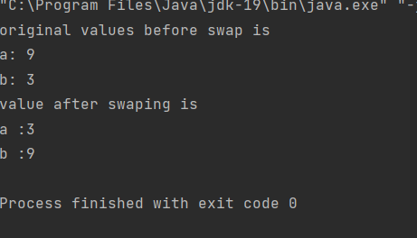

**Q3:REVERSE AN ARRAY**

**CODE:**

**static void swapinarr(int []arr,int i , int j){**

**int temp=arr[i];**

**arr[i]=arr[j];**

**arr[j]=temp;**

**}**

**static void reverse(int []arr){**

**int n=arr.length;**

**int i=0;**

**int j=arr.length-1;**

**while(i<j)**

**{**

***swapinarr*(arr,i,j);**

**i++;**

**j--;**

**}**

**}**

**static void printarray(int []arr){**

**for (int i = 0; i <arr.length ; i++) {**

**System.*out*.println(arr[i] +" ");**

**}**

**}**

**public static void main(String[] args) {**

**// q1**

**Scanner sc=new Scanner(System.*in*);**

**int n=7;**

**// ;**

**int[] arr={1,2,3,4,5,6,7};**

***reverse*(arr);**

***printarray*(arr);**

**}**

**}**

**OUTPUT:**

**7**

**6**

**5**

**4**

**3**

**2**

**1**